[A 2.5 Inch Vertical Margin, Free of Text, Required Across the Top of Page]

UTILITY EASEMENT AND RIGHT OF WAY

STATE OF ARKANSAS )
) KNOW ALL MEN BY THESE PRESENTS:
COUNTY OF BENTON )

That the undersigned [name of landowner(s)] (“Grantor” or collectively “Grantors”), for and in consideration of the sum of One Dollar ($1.00), and other good and valuable consideration, the receipt and sufficiency of which are hereby acknowledged, to [me/us] in-hand paid by Rogers Water Utilities of Rogers, Arkansas [does/do] hereby grant, bargain, and sell unto Rogers Water Utilities of Rogers, Arkansas, the Rogers Waterworks and Sewer Commission of Rogers, Arkansas, and the City of Rogers, Arkansas, a municipal corporation, (collectively “Grantee”), and its successors and assigns, permanent and perpetual easements and rights-of-way to locate, re-locate, lay, re-lay, construct, re-construct, remove, enlarge, expand, maintain, inspect, patrol, repair, replace, use, and operate utility lines and/or pipelines, including, but not limited to, water lines, water transmission lines, water main lines, sanitary sewer lines (including, but not limited to, sewer collection and/or force main lines), and all utilities, structures, facilities and appurtenances thereto, including but not limited to, above and below ground valves and piping, standpipes, meters, meter equipment, manholes, hydrants, and all other necessary appurtenances, and to perform all other tasks pertaining to said utility lines and/or pipelines, together with the right of ingress and egress to and from same, on, over, across, through, and under the following described real estate as recorded in book ____ page ____ of the instrument records of the Circuit Clerk and Ex-Officio Recorder of Benton County, Arkansas:

[Identification of land and document number, deed book and page,] located in the office of the ex-officio recorder of Benton County, Arkansas.

Said easement(s) [is/are] described as follows:

A permanent easement and right-of-way across the above-described land more particularly described as follows:

[legal description of easement and right of way; metes and bounds]; [repeat for additional easements]

Also a temporary construction easement and right of way of sufficient area to allow construction of said utility lines and/or pipelines utilities, structures, facilities and appurtenances thereto with an anticipated construction duration of __ calendar days (not including any delays due to weather) (The estimated duration is a non-binding estimate only and the temporary construction easement will continue until construction is completed). Any parking areas or landscaping disturbed by construction will be restored to pre-construction conditions.

[A] sketch(es) of this grant [is/are] attached hereto and incorporated by reference as exhibit(s) “A” [additional exhibit letters] and is to be considered as a part of this easement document. It is understood that [this/these] [sketch/sketches] [is/are] descriptive only of the approximate size, shape and location of the easement(s) and rights-of-way and [does/do] not constitute a plat or survey of the [Grantor’s/Grantors’] property.

Grantee shall have and is hereby granted the right of laying, re-laying, constructing, re-constructing, enlarging, locating, re-locating, inspecting, patrolling, operating, using, expanding, maintaining and/or removing utility lines and/or pipelines, utilities, structures, facilities, and appurtenances (including, but not limited to, new utility lines and/or pipelines, utilities, structures, facilities, and appurtenances; existing utility lines and/or pipelines, utilities, structures, facilities, and appurtenances; and/or such additional utility lines and/or pipelines, utilities, structures, facilities and appurtenances as may be required in the future). Further, Grantee shall have and is hereby granted the right to perform all other tasks, not otherwise listed herein above, pertaining to said utility lines and/or pipelines, utilities, structures, facilities, and appurtenances.

Grantee shall have the right of ingress and egress on, over, along, across, through, and under adjacent lands owned, leased, or controlled by Grantor[s] to and from said easements and rights-of-way for any and all purposes relating to, or in any way connected with, the laying, re-laying, construction, re-construction, enlargement, location, re-location, inspection, patrolling, operation, expansion, maintenance, removal, and/or use of utility lines and/or pipelines, utilities, structures, facilities, appurtenances, and all other property of Grantee located on the easements and rights-of-way described above. Further, Grantee shall have the right of ingress and egress on, over, along, across, through and under adjacent lands owned, leased, or controlled by Grantor[s] to or from said easements and rights-of-way in order to perform all other tasks, not otherwise listed herein above, pertaining to said utility lines and/or pipelines, utilities, structures, facilities, and appurtenances.

Grantee shall have and is hereby granted the further right at all times to remove from said lands all crops, vegetation, undergrowth, trees, and parts thereof, or other obstructions, which, in the opinion of Grantee, restrict access to, constitute a hazard, or endanger the safety, reliability and/or functionality of said utility lines and/or pipelines, utilities, structures, facilities, and appurtenances, and/or endanger the public and/or public safety. Grantee shall also have and is hereby granted the further right at all times to remove from said lands all crops, vegetation, undergrowth, trees, and parts thereof, or other obstructions, for the purpose of installing additional utility lines and/or pipelines, utilities, structures, facilities, and appurtenances and/or for the purpose of performing the various other tasks and actions described herein above.

The Grantor[s] and/or [its/his/her/their] successors or assigns shall not cause to be constructed any buildings, structures, or other improvements, other than “fences” within the above-described easements and rights-of-way. As used herein, the term ‘fences” does not include walls, walled fences, or combination wall/fences, or any other structure that cannot be readily dismantled if necessary. Further, no trees shall be planted by Grantor[s] or [its/his/her/their] successors or assigns on said easements and rights-of-way. Neither Grantor[s] nor [its/his/her/their] successors or assigns shall be entitled to any compensation for fences, trees, vegetation, undergrowth, crops, and/or structures which may be removed or disturbed within [this/these] permanent easements and rights-of-way by virtue of Grantee’s exercise of the rights under this agreement. It is further understood that Grantee’s easement(s) and rights-of-way shall be exclusive and that Grantor[s] and/or [its/his/her/their] successors and assigns shall convey no parallel and/or otherwise conflicting rights to any person, utility or corporation on, across, through, or under said easements and rights-of-way without the express written permission of Grantee.

The consideration hereinabove mentioned is paid by Grantee and accepted by Grantor[s], [its/his/her/their] successors and assigns, as full and total payment for the easements and rights-of-way, trees, crops, vegetation, undergrowth, or other obstructions, trimmed or removed from said lands during the construction and maintenance of Grantee's utility lines and/or pipelines, utilities, structures, facilities and all other property of Grantee located on the easements and rights-of-way described above; any and all other claimed damages, of any type, to [Grantor’s/Grantors’] land; and for all other rights and privileges hereinabove set forth.

TO HAVE AND TO HOLD the above-described easements and rights-of-way unto said Grantee, their successors and assigns, forever or until said easements and rights-of-way are finally abandoned.

And Grantor[s] agree[s] to forever warrant and defend the above described easements and rights-of-way unto said Grantee against any and all claims whatsoever.

[This/These] easement(s) and rights-of-way [is/are] declared to and [does/do] inure to the benefit of the public generally, shall run with the land, and shall be binding upon the successors in title and/or interest to the lands herein described or any other part thereof, their mortgagees, lessees, heirs, administrators, executors, successors, and assigns.

IN WITNESS WHEREOF the hand and seal of Grantor[s] is hereunto set, this day of ____________________, 20___.

[NAME OF PERSON/ENTITY] [NAME OF PERSON/ENTITY]

BY: ______________________________ BY: ______________________________

TITLE: ____________________________ TITLE: ____________________________

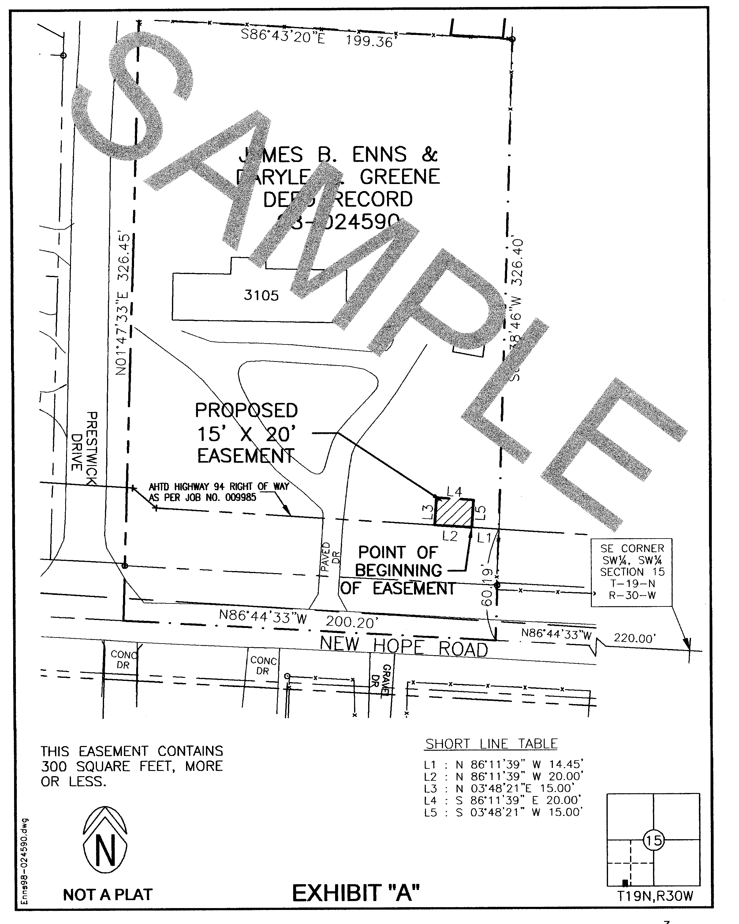

ACKNOWLEDGMENT

STATE OF ARKANSAS )
)
COUNTY OF BENTON )

BE IT REMEMBERED, that on this date, before me, a Notary Public within and for said County and State, duly commissioned and acting, personally appeared__________________, to me well known as the persons who executed the foregoing Utility Easement and Right of Way, and that they have executed the same for the consideration and purpose therein mentioned and set forth.

WITNESS my hand and seal on this day of , 20___.

_____________________________
Notary Public

My commission expires ______________________.

[A 2.5 Inch Vertical Margin, Free of Text, Required Across the Bottom of Page]

